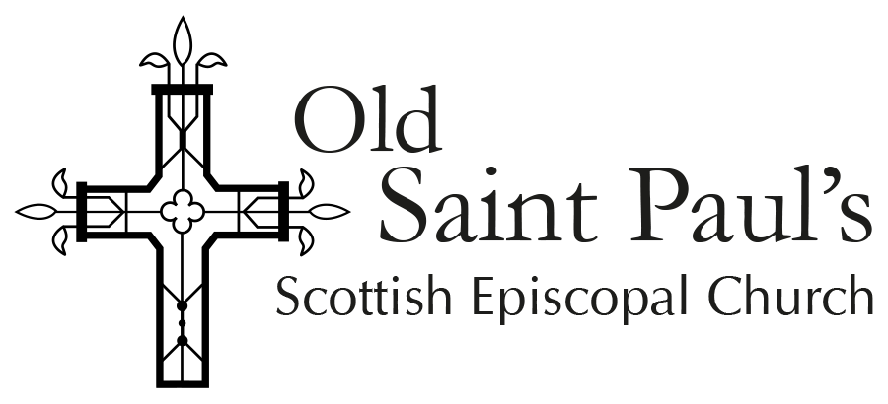

Tithing Application Form

Every year, Old Saint Paul’s gives a proportion of its charitable income to the good works of other organisations. This forms part of our mission and tithing in response to God’s generosity and love. It also allows us to support specific causes that are close to the heart of our congregation, to build links with the community and to learn from the expertise of other charities.

We typically support three charities a year. Funding for one year may be increased to a maximum of three if suitable. If you would like to suggest a charity for the church to support, please fill in the details below and send them to office@osp.org.uk by 15th May 2022.

We ask each supported charity to provide a short article for the White Rose Newsletter consisting of 250 words and one or two images.

- Name of the charity

- Web address

- Address of the charity office. For non-UK charities please give the address for a UK-based office or representative.

- Name and contact details of person making this request and the name of the charity representative who supports this request (if not the applicant).

- Brief details of the charity’s operation and aims

- Link to the most recent Annual or Financial Report. If a link is not available, please include an electronic copy of the report with this form.

- Link to OSCR, Charity Commission (or similar) registration page if available.

- How much money are you requesting? Typical amounts have range from £250 to £3000.

- What will the money be used for? Please be as brief as possible. [100-300 words is usually sufficient]

- Please describe any correspondence or existing links with the charity, for example being involved with a particular project.

- We are able to support charities that operate in the UK or overseas. Please describe:
  - where your chosen charity’s operations are based

  - [optional] any connections that might be made between OSP and your nominated charity.

Agreed by Vestry 28th February 2022

