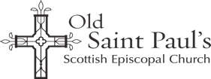
Registered Scottish Charity number SC017399

Registration & Consent Form

Name:

Address:

Phone:

Mobile:

Email:

Please delete as appropriate:

I am 16 years of age or older. Yes or No

I am happy to be contacted by the following means* (please delete as appropriate): Post, Email, Landline, Mobile, Text

I would like to receive The White Rose e-Magazine by email. Yes or No

I would like to be included on the Congregational Roll. Yes or No

I have been baptized (or christened). Yes or No

Declaration:
I have read and understood the aforementioned information and the details I have provided are accurate.

Signature:

Date:

Please submit the completed form:
- By email: office@osp.org.uk
- By post: The Administrator, Old Saint Paul’s, 39 Jeffrey St, Edinburgh, EH1 1DH
- Or in church: Hand the completed form to a member of the welcoming team.

*Please note that you can change or revoke your communications consent at any time by contacting Old Saint Paul’s with your request. Our privacy policy is accessible at https://www.osp.org.uk/privacy-notice/.

